Name –1)Prathamesh. R. Pawar

2)Prathmesh. R. Netawate

3)Aryan. J. Patil

College Name- Datta Meghe College of Engineering

Domain – Smart City

Requirement Document

1.1 INTRODUCTION

In today’s world where technology has transcended all barriers it has now become easy to solve most human problems and one of these problems include traffic congestion. We often used the quote that time is money and lot of time is being utilized in traffic. Traffic congestion has increased drastically over the years and has had negative impacts that include road rage, accidents, air pollution, wastage of fuel and most importantly unnecessary delays. One of the many causes of traffic congestion is improper traffic management systems.

1.2 SCOPE

The Website/App has been majorly focused on the time prediction for traffic and vehicles on congestion While the user can also give the alerts which can be used by traffic police team, admin in case of unexpected scenario like sudden accident of huge automobiles during the working road or due to mistake of driver.

1.3 User Stories

As a traffic analyst, I want to be able to upload and analyze historical traffic data for a specific area so that I can identify traffic patterns and provide insights to users.

1) Data should be uploaded to the system in a CSV or similar format, data analysis should be done in real-time, and the system should provide insights on traffic patterns such as peak hours, average speed, and congestion hotspots.

As a city planner, I want to be able to view real-time traffic information for a specific area so that I can make informed decisions on road infrastructure and public transportation planning.

2) Dashboard should display real-time traffic data for a specific area, dashboard should provide analytics on traffic patterns, and dashboard should allow for customization of data filters.

As a driver, I want to be able to view real-time traffic information for my planned route so that I can make informed decisions on the best route to take.

3) Real-time traffic data should be displayed on a map-based interface, the interface should allow for customization of data filters, and the interface should provide alternative routes to avoid congestion.

As a system administrator, I want to be able to manage and update the dataset used for traffic analysis so that the system remains up-to-date with current traffic patterns.

4)Dataset should be stored in a database, the system should allow for updates to the dataset, and the system should automatically incorporate the updated data into traffic analysis.

As a traffic authority, I want to be able to receive notifications for any unusual traffic patterns or accidents on a specific road or place so that I can take immediate action to manage traffic flow.

5) The system should monitor traffic patterns in real-time, the system should detect any unusual traffic patterns or accidents, and the system should send notifications to traffic authorities in real-time.

1.4 Requirements

1. Data Management

Data analyst should be able to upload and store historical traffic data in a database.

1. Traffic Analysis -

The system should be able to analyze historical traffic data to identify traffic patterns. The system should be able to provide insights on traffic patterns such as peak hours, average speed, and congestion hotspots.

1. User Interface-

The dashboard should provide analytics on traffic patterns.

The dashboard should allow for customization of data filters.

1. Alerts and Notifications

The authenticated user should be able to send notifications to traffic authorities in real time for any unusual traffic patterns or accidents on a specific road or place.

1. System Administration -

The system should have a user management module that allows administrators to add, delete, and modify users

1.5 Constraints

Data Quality: The accuracy and quality of the data used for traffic analysis will impact the effectiveness of the system. If the data is incomplete, inaccurate, or outdated, it could lead to incorrect conclusions and ineffective recommendations.

Data Availability: The availability of real-time data could be a constraint, as some data sources may not provide real-time access or have limited availability. This could impact the accuracy and timeliness of the system's insights and alerts.

1.6 Required Tools

1. Backend API using flask, Fast API, uvicorn , gunicorn.

2. Authentication using Python library flask_ login.

3. Late traffic prediction data set from Kaggle.com.

1.7 About Dataset

This data set contains observations of the number of vehicles each hour in four different junctions:

1) Date-Time

2) Junction

3) Vehicles

4) ID

Author name- Fed Soriano , Spain Data Scientist

1.8 Assumptions

Availability of Sufficient Historical Data: Assuming that there is a sufficient amount of accurate historical traffic data available for the area of interest, which can be used for analysis and identification of traffic patterns.

Reliable and Real-time Data Sources for collecting data: Assuming that reliable and real-time data sources, such as traffic cameras, GPS data, and other relevant sensors, will be available for collecting real-time traffic data for analysis and monitoring.

1.9 Conclusion

The following project has the features of the alert system and the predictive nature of the traffic with the historical data set while controlling the traffic congestion. The application will primarily help the end users such as drivers, passengers ,traffic police team with the traffic scenarios.

2. UML DIAGRAMS

2.1 User Case Diagrams –

The Following diagram display the entity relationship between the users, traffic Analysis, Admin.

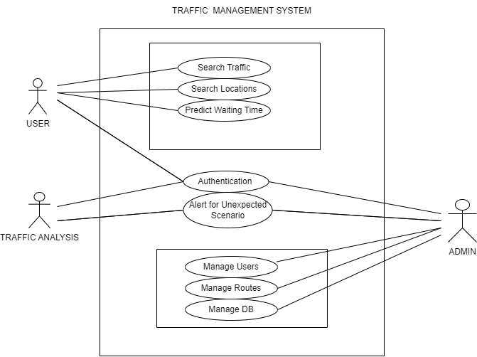

Diagram 2.1

2.2 Sequence Case Diagram

The following Sequence case diagram represents the prototype of the application.

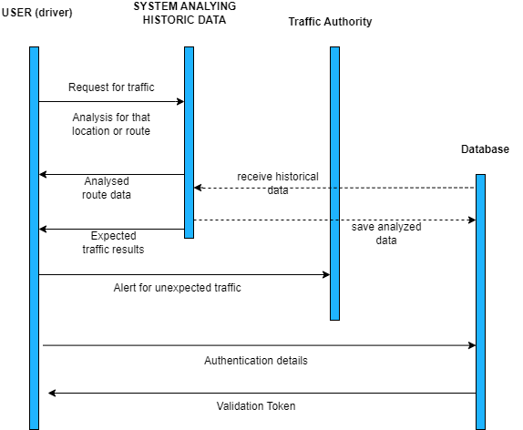

Diagram 2.2

2.3 Activity Diagram

The following is Activity diagram

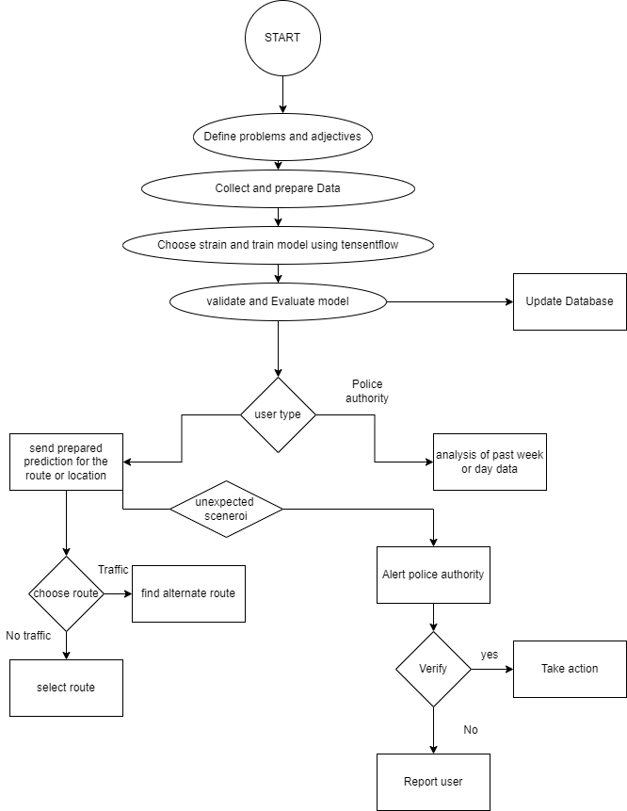

Diagram 2.3

3 Source License Statement

We have GNU (General Public License) for our project which will benefit for protection of user's freedom, Collaborative development, Legal protections and open source contributing to it.